# **DragonTale**

**Game Manual**

Desenvolvimento de Jogos de Computador

2017/2018

Developed by:

Andreia Cristina de Almeida Rodrigues - 201404691

Eduardo Miguel Bastos Leite - 201204972

Francisco Tomé Neto Queirós - 201404326

Ka Chon Ho - 201711244

# Description

DragonTale is a RPG and Adventure game that tells the story of a dragon and his mission to save the princess from an evil prince. In order to achieve this, he must battle enemies in turn-based combats. Additionally, the player can find items that tell more about the story.

# Installation

DragonTale comes as a standalone folder with executable and data inside. Just open the executable and play the game.

# Main menu

In this menu, the player can start a new game, resume a previously started game from an existing save file, change some application settings or quit the game.

# World view

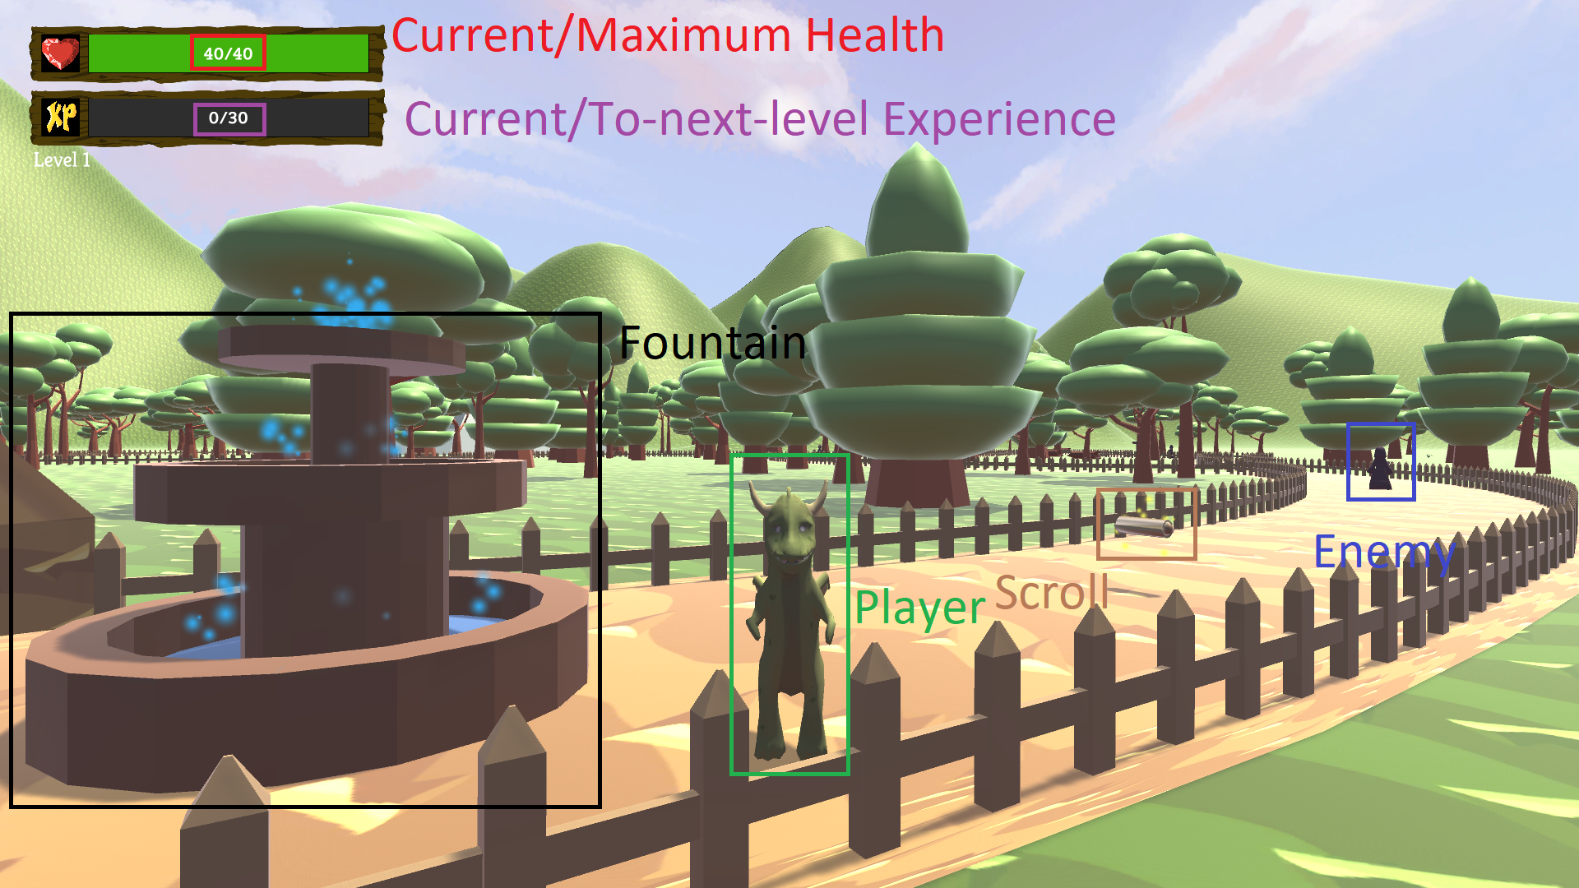

In this scene, the player can move using the WASD or the arrow keys, rotate the camera horizontally with the mouse or zoom in/out with the mouse wheel. The player will be presented with user interface showing the player's health, experience and level.

In the world, the player will find three types of entities: scrolls will tell pieces of the story, enemies that on collision start a battle sequence and fountains that heal the player and save the game.

The player will also find some vines blocking the way that can only be removed by entering certain parts of the world.

# Battle view

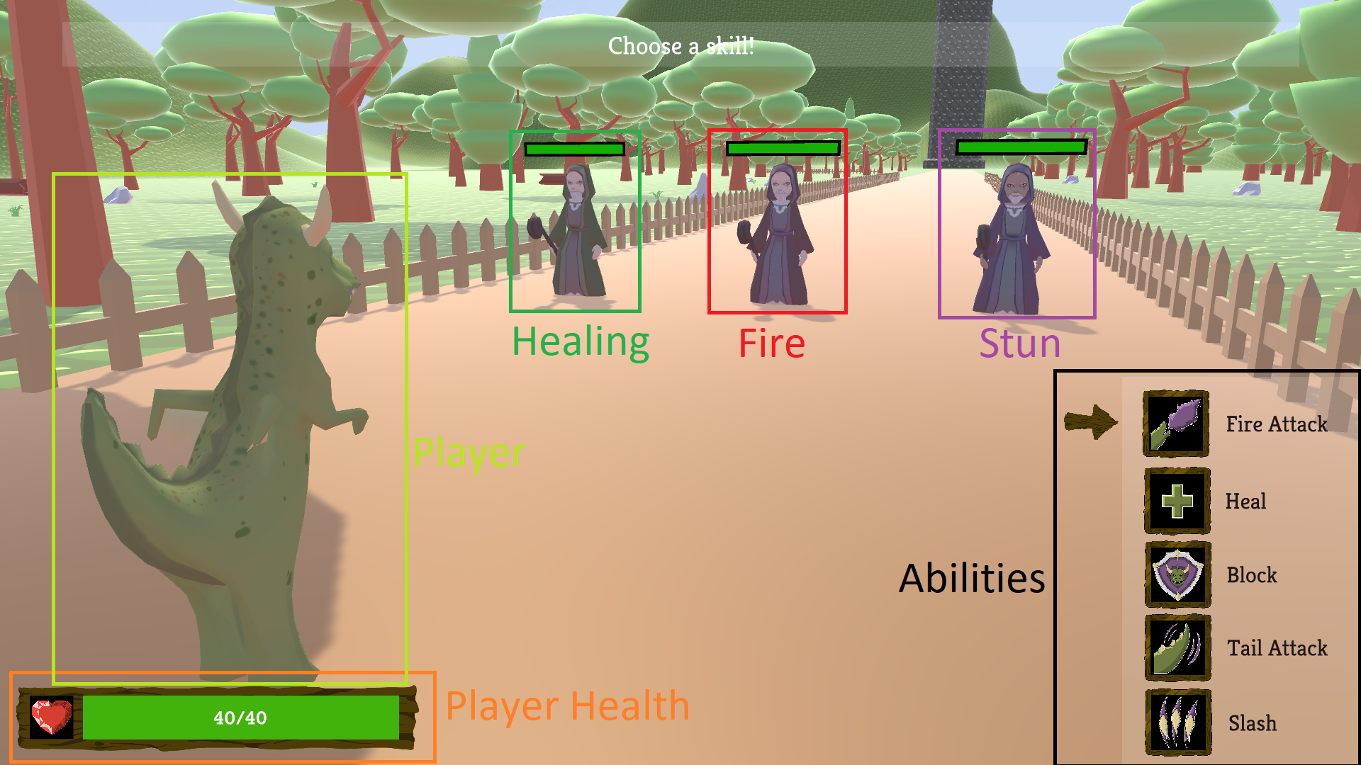

This is the scene where battles occur. They work in a turn-based fashion and the player always goes first, then each enemy gets a turn.

In the player’s turn, the player can select an ability from the list on the lower right hand corner by using the up and down arrow keys. Some abilities have a cooldown period, measured in turns, and they can't be used until the cooldown period finishes. To account for this property, the user interface skips unusable abilities when selecting.

After the player has the indicator on the desired ability, pressing enter will continue to a new phase where the player must now choose an enemy to use the ability on. To browse through the enemies, the player must use the left or right arrow keys. When the indicator is on the desired target, pressing enter will cause the player to use the previously selected ability on the selected enemy. Some abilities don't have the need for a target. In these cases, this phase is skipped.

The enemy units will then have their turns. There are 4 types of enemies: Fire, Stun and Healing mages and the prince. Both fire mages and the prince only have one type of attack that simply deals damage to the player. The stun mages will use a stun ability every third turn that stuns the player and prevents the player's next turn. If the player has used the block ability, this stun effect is blocked. On other turns, they'll use the normal fire ability. The healing mages will use a healing ability every second turn that has a wounded ally, otherwise they will use the normal fire ability on the player.

It’s up to the player to find the right combination of skills to beat the several obstacles, every skill has a purpose.